UR-8 Universal Receiver
The Universal Receiver connects any kind of alarm device e.g. siren or strobe light to a Control Panel.
When an alarm is triggered, the Control Panel signals the Universal Receiver which then will activate the alarm device. The Universal Receiver activation can be stopped via the Control Panel.
LED
Device Connection Terminal
Function Switch Block
Output Selection Jumper
Buzzer
- Function Switch Block
Carefully slide down the protective cover exposing the switch block set that consists of 7switches marked (1 ~ 7) left to right. A switch in the up position indicates the (ON) mode. Likewise, a switch in the down position indicates the (OFF) mode. Switch function table is below:
SW1 |  | Siren Learning
ON |  | Learning Mode
OFF |  | Normal Operation
SW2 |  | Control Unit type and Activation Mode
ON |  | CTC-909, CTC-918, CTC-1132 and 1142 Remote Access control and panel alarm.
OFF |  | Panel alarm only. NOTE: Switch has to be in OFF position for the CTC-911, CTC-922, CTC-1130, 1131 and 1140 panels.
SW3 | SW4 | Relay Operation Mode
ON | ON | Latch until reset
OFF | ON | Reserved
ON | OFF | Pulse on for 3 min
OFF | OFF | System Arm/Disarm Status only, irrespective of SW5 and SW6 position
SW5 | SW6 | Alarm type
ON | ON | Burglar Alarm
OFF | ON | Fire Alarm
ON | OFF | Water Alarm
OFF | OFF | All Alarms
SW7 |  | Memory Reset
ON |  | Memory Clear
OFF |  | Normal
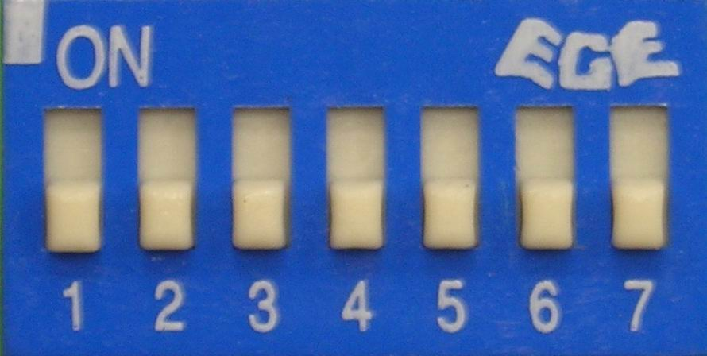

- (SW2) is only programmed for CTC-909, CTC-918, CTC-1132 and CTC-1142 special functions.
URA-8 ON – Activation using one of the following methods:
- Remote access via SMS or DTMF. Please refer to Control Panel operation manual.
- Control Panel when an alarm is triggered.
URA-8 OFF – Activation can only be done by Control Panel when alarm is triggered.
<NOTE>
    - For the CTC-911, CTC-922, CTC-1130, CTC-1131 and CTC-1140, SW2 must be set to (OFF) i.e. the URA-8 can be activated only by Control Panel when alarm is triggered.

- SW3 & SW4 are used to program UR operation modes:
- Latched – once the relay has been activated, it will remain activated until disarmed.
- PULSE – activated for 3 minutes each time.
- System Status On:
  - Away / Home Mode – Relay Activation
  - Disarmed Mode – Relay Deactivation
- Output Selection jumper(JP2)
Dry contact relay or DC 12V output selection
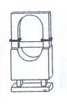
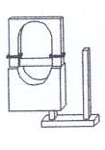
Jumper on, with link inserted between two pins – DC 12V output is selected. (Factory Default)

Jumper open, with link removed or parked on one pin – Dry Contact relay output is selected.
- POWER SUPPLY:
- The URA-8 can be powered by 12V DC Power Adaptor or connecting an external DC 12V directly to Pin 1 & Pin 2 of the Device connection terminal.
- A factory 12V DC 300 mA adaptor is provided. However, a device requiring a larger current should be used with an appropriate power adaptor accordingly.
- DEVICE CONNECTION TERMINAL:
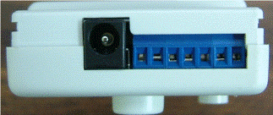
Pin 7: NA
Pin 5: Relay-N.O.
DC Jack
Pin 1: DC 12V In/Out
Pin 2: GND
Pin 6: NA
Pin 3: Relay-N.C.
Pin 4: Relay- Common

Side View

- Pin 1 & 2 provide constant DC 12V Output or can be used as DC 12V Input
          - Pin 1 is (+) polarity
          - Pin 2 is (–) polarity (Ground)
          - If an adaptor is used, Pin 1 & 2 Provide DC 12V output. If the adaptor is not used, an external DC 12V can be connected directly to Pin 1 & Pin 2 to power the URA-8.
- Pin 3, 4 & 5 provide a Dry Contact Relay output or DC 12V output – selected by the (Output Selection Jumper)

- Relay Output (the “output selection jumper” is open)
          - Pin 3: Normally Close (NC)
          - Pin 4: Common (C)
          - Pin 5: Normally Open (NO)
- DC 12V output (the “output selection jumper” is on)
Pin 4: Common, a fixed 12V
          - Relay Activated:
          - DC 12V will switch to Pin 5; Pin 2 & 5 provides DC 12V output to drive the alarm device connected to it.
          - Relay Deactivated:
          - DC 12V will switch to Pin 3; Pin 2 & 3 provides DC 12V output to drive the alarm device connected to it.
- Output Capacity:
          - For relay output, the contact capacity is 1A 30VDC / 1A 120VAC.
          - For DC 12V output, the maximum current has the same rating as the Power Adapter (=300mA).
- LEARN-IN URA-8:
Step 1: Supply power by adaptor or external DC 12V
- When power is ON, the LED will flash 3 times and 3 beeps will sound, and then the LED off before URA-8 is learned-in.
Step 2: Enter Learn Mode using a sharp object to slide SW1 up to (ON) position.
- LED flashes rapidly once per second.
Step 3: Program the Control Panel by selecting (Device +/-) menu, then (Program Siren) menu, then depending on the usage of the URA-8, follow one of the methods below:
Use with CTC-911/CTC-922CTC-1130/CTC-1131/CTC-1140:
Step 3A: Make sure the SW2 is in Down (OFF) position.
Step 4A: Select (Learn Siren) in the Control Panel
Step 5A: Press (OK)
Use with CTC-909/CTC-918/CTC-1132/CTC-1142, the URA-8 is activated only when the alarm is triggered:
Step 3B: Make sure the SW2 is in Down (OFF) position.
Step 4B: Select (Learn Siren) in the Control Panel
Step 5B: Press (OK)
Use with CTC-909/CTC-918/CTC-1132/CTC-1142, the URA-8 can be activated by Remote Access via SMS or by Control Panel when the alarm is triggered:
Step 3C: Slide SW2 to Up (ON) position.
Step 4C: Select (Receiver 1) or (Receiver 2) in the Control Panel. (Use the (down) key to select from the bottom menu.)
Step 5C: Press (OK)
Step 6: The Control Panel will sound a long beep and the LED lights steadily for 3 seconds indicating Learning is now complete.
Step 7: Slide SW1 back down to (OFF) position to exit learn mode and enter Normal Mode.
- LED will flash every one second representing normal operation.
<NOTE>:
    - After learning process completion, SW2 adjustment will not be available.
    - Any mode change requires SW2 reset.
- INSTALLATION:
Step 1: Locate a suitable spot for URA-8 mounting.
Step 2: Use the mounting bracket as a template to mark off the hole positions.
Step 3: Drill 2 holes and insert wall plugs into holes.
Step 4: Use screws to tightly secure mounting bracket.
Step 5: Hang the URA-8 on the bracket.
Step 6: Connect the alarm device to the URA-8 then install the alarm device location.
Step 7: Slide SW3 and SW4 into the preferred Relay Operation Mode setting.
Step 8: Slide SW5 and SW6 into the preferred Alarm type setting.
Step 7: Plug the power adaptor into wall outlet and cord into DC jack,
- When power is ON, the LED will flash 3 times and 3 beeps will sound.
- The LED will flash slowly indicating the power adaptor is properly connected and the URA-8 is learned-in already. The LED off indicates URA-8 is not learned-in..
Step 8: The URA-8 is now ready for operation.
- NORMAL OPERATION:
- The LED flashes every one second indicating normal operation.
- When the Control Panel receives an Alarm Code the Relay is active for 3 minutes (if programmed) or until (Disarm) code is received.
- LED stops flashing and lights steadily for as long as the relay is active.
- The URA-8 automatically deactivates the Relay output when (Disarm) code is received from Control Panel and the URA-8 returns to Normal Operation Mode with flashing LED.
- RESET URA-8:
Resetting URA-8 should be done whenever Operation Mode needs changing or the URA-8 malfunctions.
Step 1: Slide SW7 up to (ON) position.
Step 2: Remove power by unplugging the AC adaptor.
Step 3: Replace the AC adaptor and supply power back to the URA-8.
Step 4: Slide SW7 back down to (OFF) position. LED will flash 3 times and 3 beeps will sound and the URA-8 returns to Normal Operation Mode with LED off indicating a successful reset.
<NOTE>:
    - After reset, the URA-8 requires to be again learned-in before normal operation.

